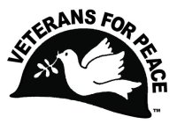
Veterans For Peace - Chapter 74 – Metro Detroit Area Chapter
Wayne, Oakland, Macomb, Monroe Counties
www.vfp74.org - Steve Saelzler - Chapter Coordinator - saelzler@comcast.net – 734-675-4138 (home) – 734-674-0688 (cell)
Also, visit us on Facebook, and “like” us at www.facebook.com/VFP74

October 2020 VFP Chapter 74 News Update

Receiving this Update by email but not yet a Veterans For Peace member? Please consider joining! Non-veterans can join as an Associate Member. The more VFP members there are, the more we can do. For membership information visit www.veteransforpeace.org/take-action/join-renew

1. Next VFP Chapter 74 Meeting – Saturday, October 17th – 2pm – By Teleconference Only
Due to the Corona pandemic, and the closure of our regular (Swords Into Plowshares Peace Center) meeting location, the Saturday October 17th Veterans For Peace Chapter 74 meeting will be by teleconference only. There will be no face-to-face meeting. To participate, at 2pm, October 17th, dial 563-999-1129 and when prompted, enter the Access Code of 721444. Anyone can participate in this meeting, or any other VFP Chapter 74 event, be they veteran or not. The meeting agenda is below…

- Introductions and welcome
  - VFP mission statement
  - Members and guests present – Member news
- General business
  - Treasury report
  - Membership
  - Other
- Old Business
- Peace Pole WSU
- Other
- New Business
  - Arlington Michigan Veterans Day display in Ann Arbor
  - Other
- Upcoming events
- Adjournment – Next Meeting Date

2. Remember To Vote! Last Day to Register to Vote ONLINE is Oct 19th
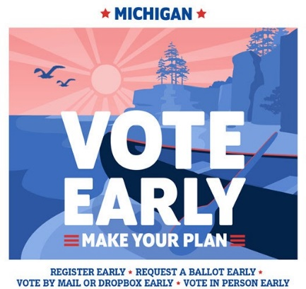
- Election day is Nov. 3
- Registration deadlines
        - Online: Oct. 19 or by mail, Postmarked by Oct. 19
        - In person: Nov. 3

The 2020 General Election is approaching in just a few weeks, so it’s a good idea to make sure you’re registered to vote in advance. If you haven’t already registered to vote in Michigan, there is still time to do so. Michigan residents can register to vote at any time up to 8 p.m. on Election Day -- in this case, November 3 -- at their city or township clerk’s office. If you choose to register to vote with your local clerk in person after October 30, you will be required to vote the ballot in-person at that time. If you are registering another way, your completed voter registration application must be received or postmarked by October 19, 2020 in order to vote in the November General Election.

Absentee ballot deadlines
- Request: Received by Oct. 30 by 5:00 p.m.
- Return by mail: Postmarked by Nov. 2
- Return in person: Nov. 3 by 8:00 p.m.

Early voting -Sep. 24 - Nov. 2, but dates and hours may vary based on where you live.
Additional information - Michigan does offer registration on Election Day at designated locations in each town. It is not available at your polling place.
3. Arlington Michigan Display For Veterans/Armistice Day In Ann Arbor
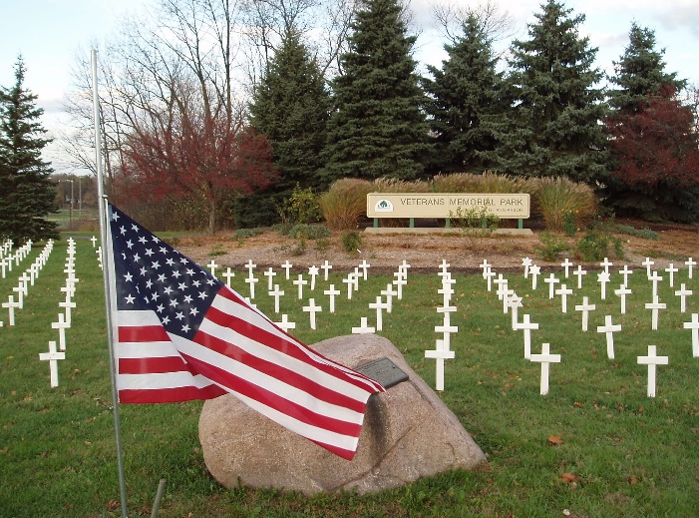
Wednesday, November 11th, 11am until dusk, Veterans Park, Maple and Jackson Roads, Ann Arbor. Veterans/Armistice Day memorial display of one marker for every Michigan soldier lost in the Iraq and Afghan wars (230 markers). The purpose of this display is to honor those who have fallen, to provide a place to grieve, and to educate the public about the costs of war, as well as the needs of those returning from conflicts. Peace ceremony at 11am.

Display is at the southwest corner of Veterans Park with parking at the Veterans Memorial Ice Arena parking lot (2150 Jackson Avenue, Ann Arbor, MI 48103). Sponsored by Veterans For Peace Chapter 93. Free. Details: www.vfp93.org, www.facebook.com/events/363086908074857, or call (734) 487-9058. If you would like to help set up the display, please show at Veterans Park at 10am. For more on Veterans/Armistice Day visit www.veteransforpeace.org/take-action/armistice-day.

4. Become An Election Defender November 3rd!
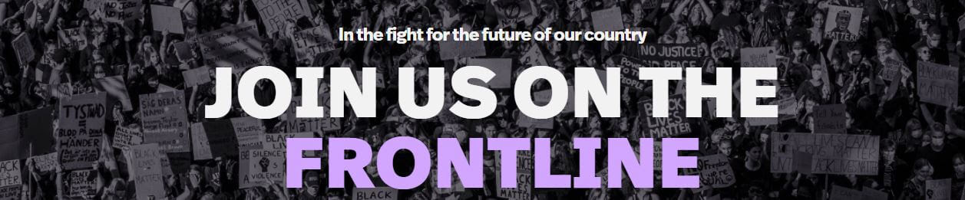
With the stakes being as high as they are, voter suppression already more rampant than ever, and the nationalist right emboldened by conspiracy theorists and the President himself, we are depending on you else to ensure people are able to vote freely and safely.
How can you help? By becoming an Election Defender. Unlike traditional poll watchers, Election Defenders will be working to provide safe supports for voting (such as PPE and water), election & voter defense, de-escalating right-wing intimidation tactics, and signaling to a network of groups and lawyers if and where trouble breaks out. We need you on election day!
Veterans For Peace and About Face (Formerly Iraq Veterans Against The War) are part of a united front effort with hundreds of other mass-member organizations to ensure free and fair elections. Protecting the rights of people to vote in-person on November 3rd means thousands of people signing up for different roles. Signing up today means you’ll have access to weekly training and a slack channel where our efforts can be coordinated around the nation.
Click here to sign up! - Follow the Frontline on FB
5. VFP’s Climate Change Committee And Website
VFP national has established a climate change committee, headed by Steve Morse of Chapter 69. Jim Rine, a member of Chapter 74 and an adjunct professor in the geology department at Wayne State University, is a member. The committee currently meets every two weeks via Zoom.

One of the members of the VFP climate committee launched the website Vote Climate 2020 - https://voteclimate2020.org/ . According to the website “Vote Climate 2020, a 24-7 global internet streaming broadcast, was founded by … Robert Manning, an 84-year-old, blind, retired firefighter in Walnut Creek, California. His vision is to use the internet and powerful videos to tell the climate crisis story and mobilize people to vote. Supported by his family and friends, that vision is now using powerful factual and music videos to deliver a “Vote Climate” message around the world. He asks people to speak out and share that message with everyone they know through their personal and social networks.”

6. VFP In The Media
- War Is A Disaster, Not A Game by Pete Doktor and Ann Wright
- If Trump Tries to Hijack the Election, We Must Be Ready to Resist

7. And The Government Can’t Help Schools?
From Win Without War - https://winwithoutwar.org

Even for a team used to Pentagon budgets numbering in the trillions, news that former Lockheed Martin CEO Robert Stevens is listing his River View Estate for an eye-popping $60 MILLION took us aback. Stevens reportedly spent “tens of millions of dollars designing and constructing a new home and doing infrastructure work” — that’s tens of millions of dollars inextricably linked to his work at the world’s top weapons contractor.

Today marks the NINETEENTH anniversary of the U.S. invasion of Afghanistan. Nearly two decades and two TRILLION dollars later, there is little to show but hundreds of thousands hurt and killed. You know who STILL comes out on top in this scenario? War profiteers like Lockheed and their CEOs. A significant portion of the almost FIVE TRILLION dollars spent on wars in Afghanistan and Iraq since 2001 has gone to U.S. military contractors including Lockheed Martin, DynCorp, Black & Veatch, and Academi (formerly Blackwater). This is despicable. And it’s a stark reminder of how out-funded the anti-war movement is in our fight to upend the military industrial status quo.

The 2001 Authorization for Use of Military Force (AUMF) is critical to sustaining the war profiteer business model. In the last two decades, this authorization has been stretched beyond recognition, invoked to justify military actions of all types, from all-out invasions to deadly drone strikes across the globe: Afghanistan, the Philippines, Georgia, Yemen, Djibouti, Kenya, Ethiopia, Eritrea, Iraq, Somalia, and more.

It has meant blank checks to the Pentagon and lucrative contracts to dozens of weapons manufacturers. War is good for business. Endless war is even better. And the arms industry knows it. In this election cycle, U.S. weapons makers have already spent over $27 million on lobbying and campaign contributions — to members of both parties. Nineteen years is nineteen too many. Many of you have been in this fight with us since the beginning, and I’ll be honest that we’ve still got a long road ahead. It’s an honor to keep walking it together. Thank you for working for peace!

8. Take Action (Takes Two Minutes) – Stop A New Nuclear Arms Race
From Win Without War - https://winwithoutwar.org

News broke earlier this month that Trump has ordered the Pentagon to figure out how quickly it could pull nuclear weapons out of storage to load onto long-range bombers and submarines. Make no mistake: this is the unofficial start of a new nuclear arms race. The Trump administration has already pulled out of two other nuclear treaties, and these latest orders are part of a ramp-up to force the critical New Strategic Arms Reduction Treaty (START) to implode before it is set to expire in February. Trump wants a no limits nuclear world, and it is hard to imagine anything more terrifying than even FEWER limits on a president like Trump’s access to nukes.
I know there’s a lot on your plate right now. But we need EVERY voice in Congress to speak out and use ALL their political leverage if we’re going to get Trump to extend this critical treaty. Right now there is bipartisan support for a bill before the House to show support for New START, but Representative Debbie Dingell is not a cosponsor!
The assessment that the Trump administration just ordered will determine how long it would take to load nuclear weapons currently in reserve onto long-range bombers, ballistic missile submarines, and land-based missile silos to beef up the U.S. nuclear force — all in an effort to force Russia to agree to nonsensical changes to New START.
And it’s incredibly dangerous. This is exactly how arms races start: one side takes small steps and claims it’s simply anticipating what the other side will do, the other side responds in kind, and a few short steps later everyone is so armed to the teeth that even the tiniest misstep could set off a global catastrophe.
New START was designed to prevent exactly this type of scenario. This landmark agreement built on previous nuclear weapons treaties to limit the number of deployable U.S. and Russian nuclear weapons to 1,550 — the lowest level since the Cold War nuclear arms race began — and it includes unprecedented accountability measures to ensure each country honored the agreement. New START expires in just four short months, and failing to extend it would set us back to the earliest days of the Cold War, to a time when U.S. and Russian (then-Soviet) nuclear arsenals were unrestricted. We can’t let that happen without a fight.
Send your U.S. Representative an email letter now and urge them to add their name and stop Trump from ending nuclear arms control as we know it. Go to https://act.winwithoutwar.org/act/write-rep-extend-new-start to get started.
Let’s be clear: New START is not enough. “Low yield” warheads and “limited” nuclear wars — weapons and ideas boosted by this administration — are misnomers that minimize the devastating harm these weapons inflict. Win Without War is committed to a world free from the threat of nuclear war. New START is a critical beginning to how we get there. We refuse to be dragged back into the global nuclear arms race of the past. The clock is ticking.
9. Have An E-Mail Address?
If you are receiving this update by postal mail and have an e-mail address, it would be appreciated if you could forward your e-mail address to Bob Krzewinski at wolverbob@gmail.com. Your e-mail address will be kept confidential and not given to third parties.

10. Our VFP Chapter Can Use Your Help
Currently our VFP Chapter literally has only a few people doing all the work and projects and to say we could use help is an understatement. Most of these volunteer jobs don’t take up that much time at all and would help out the Chapter immensely. One thing we are trying to promote is for people to sign up for a “volunteer email list”. We always need extra people to help staff events like the Arlington Michigan (one cross for every soldier killed in Iraq/Afghanistan wars) display on Memorial Day or the VFP Chapter 74 activities. Just tell us you want to be on the volunteer e-mail list and when an event date starts rolling around, we will email you to see if you can help out. If you can, great. If not, we understand. Even if you are not a veteran, we could still use your help. To be placed on the “volunteer email list”, just send an email to Steve Saelzler at saelzler@comcast.net (or call 734-675-4138) and he will get back in touch with you. Thanks in advance for your consideration of this request!!!

11. Announcements, Anniversaries & Events
VFP National Online Social Hours
VFP has experimented with VFP Social Hours and members enjoyed the chance to chat and catch up (or meet) with other Veterans For Peace members. VFP will continue these twice a week every Tuesday and Thursday at 2 pm. (EDT). VFP will post the "Join" link in the Calendar section on the right side of the front page of our website - www.veteransforpeace.org - before every Social Hour.

Veterans For Peace National Weekly E-News List
Get updates on upcoming VFP national actions, ongoing campaigns and news from chapters across the country. Additionally, the e-news provides resources and helpful tips for engaging your own actions. To sign up visit https://veteransforpeace.salsalabs.org/eblast0/index.html

VFP John Lennon Birthday Benefit Concert Now On CD
In April 2020, Veterans For Peace Chapter 93 released a compact disc (CD) recording of the musical artists performing at their October Ann Arbor John Lennon Birthday Benefit Concerts over the years for the Chapter’s Peace Scholarship program. And like the Concert, a purchase of the CD also goes to benefit the Peace Scholarship program.

Selections on the CD include Revolution (Chris Buhalis, Peter “Madcat” Ruth), Maggie Mae (Dave Boutette, Peter “Madcat” Ruth, Dave Keeney), You’ve Go To Hide Your Love Away (Annie & Rod Capps, Jason Dennie), Lucy In The Sky With Diamonds (Billy King with Emily Slomovits and band), In My Life (Emily Slomvits with Billy King), Dear Prudence (Jo Serrapere), Across The Universe (Jen Sygit), Rest Easy Little Darlin (John Latini), Crippled Inside (Dave Keeney, Sophia Hanfi), Working Class Hero (Rochelle Clark), Come Together (Shari Kane and Dave Steele) and Imagine (Billy King).

​The John Lennon Birthday Benefit Concert CD can be purchased for $15, plus $3 for shipping, by PayPal by visiting www.vfp93.org/john-lennon-concert-cd.

VFP 74 On Facebook
Veterans For Peace Chapter 74 now has a Facebook page. To sign up, just visit Facebook (www.facebook.com) and type in Veterans For Peace Chapter 74.

Women In Black Marches
Second Saturday of every month in the Metro Detroit area with everyone welcome (men, women, children). Please wear black. You can view upcoming "Women in Black - Detroit" events at http://groups.yahoo.com/group/WIB-Detroit.

Metro Detroit Peace Events Calendar
For a complete update of Metro Detroit area events, visit the Gray Panthers of Metro Detroit website at http://www.graypanthersmetrodetroit.org/CalendarofEvents.html.

A Simple Way To Promote VFP - Wear Your VFP T-Shirt!
Help spread the word about Veterans For Peace by wearing a VFP t-shirt, sweatshirt or button around your town or in your travels. Not only does this introduce the public to the fact that there are veterans who stand for peace, but can help bring additional veterans into the organization. Don’t have a VFP t-shirt or button? Order them by visiting http://veterans-for-peace-online-store.myshopify.com/ (secure, online sales available).

Swords Into Plowshares Peace Center & Gallery
Currently closed due to the pandemic. For updates visit www.swordsintoplowsharesdetroit.org.

VFP Michigan Peace Scholarships
Applications are being taken now for the Veterans For Peace Michigan Peace Scholarships, sponsored by VFP Chapter 93. The Scholarships, out of an endowment provided by Yoko Ono to Veterans For Peace, are awarded to college students enrolled in a peace studies or conflict resolution related program. Awards are given to either Michigan residents, or students enrolled at a Michigan college, with a preference given to military veterans. For more information, visit www.vfp93.org/peace-scholarship.

