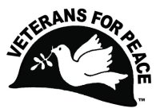
Veterans For Peace Chapter 74 – The Michael Gramlich - Metro Detroit Chapter Wayne, Oakland, Macomb, Monroe Counties
www.vfp74.org - Steve Saelzler - Chapter Coordinator - saelzler@comcast.net – 734-675-4138 (home) – 734-674-0688 (cell)
Also, visit us on Facebook, and “like” us at www.facebook.com/VFP74

November 2021 VFP Chapter 74 News Update

Receiving this Update by email but not yet a Veterans For Peace member? Please consider joining! Non-veterans can join as an Associate Member. The more VFP members there are, the more we can do. For membership information visit https://www.veteransforpeace.org/donate/join-renew

1. Next Chapter Meeting - NOTE NEW TIME AND DAY OF WEEK - Wednesday, November 17th, 7:30pm - Zoom Teleconference
The Wednesday, November 17th, 7:30pm Veterans For Peace Chapter 74 meeting will be by Zoom teleconference only. There will be no face-to-face meeting. The change in meeting day is an attempt to see if a larger audience can attend a VFP meeting if it is held on a week night rather than a Saturday afternoon.
To participate, five minutes before 7:30pm on Wednesday, November 17th, click on… https://us06web.zoom.us/j/88372237367 - To join the meeting by telephone only, call 312-626-6799 and when prompted, enter a Meeting ID of 883 7223 7367. Anyone can participate in this meeting, or any other VFP Chapter 74 event, be they veteran or not. The meeting agenda is as follows…

- Introductions and welcome
  - VFP mission statement
  - Members and guests present – Member news
- General business
  - Treasury report
  - Membership
  - Other
- Old Business
- Peace Pole WSU & Schools
- Deported Veterans Mural Project
- Mayors For Peace Michigan organizing
- Other
- New Business
- Upcoming events
- Adjournment – Next meeting date

2. Arlington Michigan Display For Veterans/Armistice Day In Ann Arbor
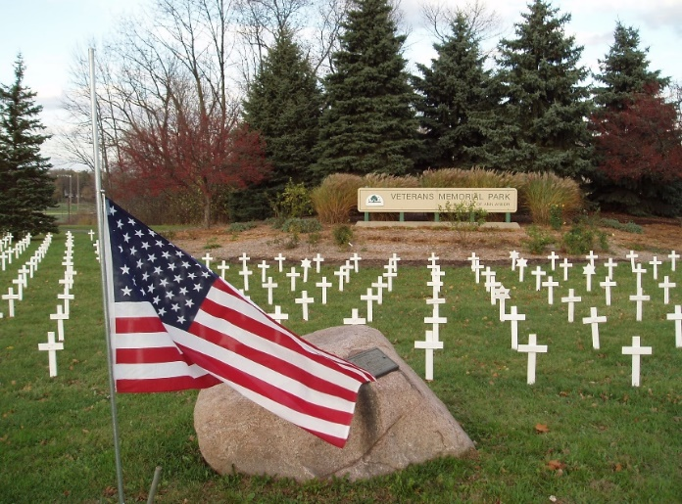
Thursday, November 11th, 11am until dusk, Veterans Park, Maple and Jackson Roads, Ann Arbor. Veterans/Armistice Day memorial display of one marker for every Michigan soldier lost in the Iraq and Afghan wars (230 markers). The purpose of this display is to honor those who have fallen, to provide a place to grieve, and to educate the public about the costs of war, as well as the needs of those returning from conflicts. Peace ceremony at 11am.

Display is at the far southwest corner of Veterans Park with parking at the Veterans Memorial Ice Arena parking lot (2150 Jackson Avenue, Ann Arbor, MI 48103). Sponsored by Veterans For Peace Chapter 93. Free. Details: www.vfp93.org, www.facebook.com/events/363086908074857, or call (734) 487-9058. If you would like to help set up the display, please show at Veterans Park at 10am. For more on Veterans/Armistice Day visit www.veteransforpeace.org/take-action/armistice-day. For the history of Veterans/Armistice Day visit www.va.gov/opa/vetsday/vetdayhistory.asp.

3. Celebrate Armistice Day 2021!
A message from the national office of Veterans For Peace…
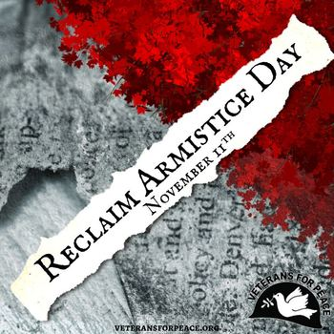
Over one hundred years ago the world celebrated peace as a universal principle. The first World War had just ended and nations mourning their dead collectively called for an end to all wars. Armistice Day was born and was designated as “a day to be dedicated to the cause of world peace and to be thereafter celebrated."

After World War II, the U.S. Congress decided to rebrand November 11 as Veterans Day. Honoring the warrior quickly morphed into honoring the military and glorifying war. Armistice Day was flipped from a day for peace into a day for displays of militarism.
Veterans For Peace has taken the lead in lifting up the original intention of November 11th – as a day for peace. As veterans we know that a day that celebrates peace, not war, is the best way to honor the sacrifices of veterans. We want generations after us to never know the destruction war has wrought on people and the earth.

Veterans For Peace has been celebrating Armistice Day almost since the organization's inception, with a few chapters doing yearly events. Since 2008, with the passing of an official Veterans For Peace resolution, it became a VFP national effort. Each year, chapters across the country "Reclaim Armistice Day" by pushing the celebration of peace into the national conversation on Veterans Day.

Veterans For Peace is calling on everyone to stand up for peace this Armistice Day. More than ever, the world faces a critical moment. Tensions are heightened around the world and the U.S. is engaged militarily in multiple countries, without an end in sight. Here at home we have seen the increasing militarization of our police forces and brutal crackdowns on dissent and people’s uprisings against state power. We must press our government to end reckless military interventions that endanger the entire world. We must build a culture of peace.

11 Things to do on the 11th (safe PDF document download) - https://tinyurl.com/VFP-Armistice-MI
Veterans For Peace Armistice Day web page - www.veteransforpeace.org/take-action/armistice-day

4. Vote Now: Veterans For Peace Members - VFP 2021 Annual Ballot
You are reminded to vote in the national Veterans for Peace VFP 2021 annual ballot. Those members who did not vote in the electronic, online balloting should be receiving a paper ballot with a voting deadline. Ballots must be postmarked by November 30th to be counted. If you have national VFP election questions visit www.veteransforpeace.org/2021ballot.

5. Veterans Week At The University Of Michigan – November 8th to the 12th
This annual event features a week of programming that educates and celebrates the experiences and sacrifice of those who have served our country. All events are free and are open to the entire university community and to the general public unless otherwise noted. Out of an abundance of caution for the health of the community and our veterans, all events will be either hybrid virtual/in-person formats or entirely virtual formats.

This year’s programs include How the Wars In Iraq and Afghanistan Impacted Medical and Civilian Critical Care (11/9), Vietnam and Afghanistan (11/10), Living With PTSD (11/10), Michael Tougias - The Untold Story of the Cuban Missile Crisis (11/10), Women Military/Veteran Panel (11/11), and The Hidden Burdens of Military Families (11/12). The full program list is at https://vets.umich.edu/vetsweek.

If you have any questions about this year’s events, please email Philip Larson, program director for U-M Veteran and Military Services, at pnlarson@umich.edu. The University of Michigan Veterans and Military Services website is at https://vets.umich.edu.

6. Militarism Fuels Climate Crisis – Take Action!
Congresswoman Barbara Lee (CA-13) introduced a resolution aimed at monitoring and reducing the carbon footprint of the U.S. military – the single largest institutional source of greenhouse gas emissions on the planet.
The resolution calls for the Department of Defense to set clear annual emission reduction targets in line with global goals in the 2015 Paris Agreement and the National Defense Authorization Act (NDAA) for Fiscal Year 2022. Read the press release by clicking here.

On a local level, Veterans For Peace Chapter 74 member Jim Rine, who also serves on the national VFP Veterans For Peace Climate Crisis & Militarism Project - www.veteransforpeace.org/take-action/climatecrisis - was quoted in the press release by Congresswoman Lee on the military carbon footprint resolution.
The press release, and a link to the actual resolution text, can be found at https://lee.house.gov/news/press-releases/congresswoman-lee-introduces-resolution-to-monitor-and-reduce-greenhouse-gas-emissions-from-the-us-military. An article on potential implications of this nonbinding resolution is Barbara Lee calls on Pentagon to release delayed emissions report - Axios .

The Climate Crisis & Militarism Project of Veterans For Peace invites you to urge your Member of Congress (MOC) to cosponsor H Res 767: Department of Defense to reduce the overall environmental impact of all military activities and missions, and for other purposes. Take action (email to Congress) by clicking here.

7. VFP Featured in PBS American Veteran Program
Veterans For Peace member Kelly Wadsworth, a former U.S. Army National Guard/Reserves chaplain and Randy Rowland, both of the Seattle chapter are featured in PBS' program American Veteran. From PBS' website: American Veteran illuminates the veteran experience with a stunning range of voices from today and across the arc of American history. The 4-part series will be on local PBS stations, ending on November 16. (Previous episodes can be seen on PBS app). For viewing times visit https://www.pbs.org/wgbh/american-veteran/watch/tv-schedule/. For the PBS American Veteran web page, visit https://www.pbs.org/wgbh/american-veteran/.

8. Announcement, Anniversaries & Reminders
Every Friday - Welcoming New Detroit Immigrants
Welcome new refugees to the metro Detroit region Fridays at Detroit’s Clark Park on the corner of Verner and Clark (map at https://tinyurl.com/ClarkPark-Map) from 3:45pm to 4:45pm. The name of the event is We Stand With Our Neighbors Immigration Vigil. This weekly vigil was stared in response to school children in Southwest Detroit whose teachers and counselors are deeply concerned about the trauma students are experiencing as they face the threat and reality of detention and deportations. Our message is: No deportations! No ban! No wall! No harassment and intimidation! Their Facebook page is www.facebook.com/WeStandWithOurNeighbors.

November 10 (Wednesday) - Climate Crisis & Militarism Project General Meeting
8pm (ET) - For Zoom information, please email climate@veteransforpeace.org

VFP National Online Social Hours – Now Every Friday At 6pm EST
VFP has experimented with VFP Social Hours and members enjoyed the chance to chat and catch up (or meet) with other Veterans For Peace members. VFP will continue these every Friday at 6pm. (EST). To join the Social Hour, go to https://zoom.us/j/324812650 or go to https://zoom.us/join and click join meeting and enter in Meeting ID: 324 812 650

Veterans For Peace National Weekly E-News List
Get updates on upcoming VFP national actions, ongoing campaigns and news from chapters across the country. Additionally, the e-news provides resources and helpful tips for engaging your own actions. To sign up visit https://veteransforpeace.salsalabs.org/eblast0/index.html.

Metro Detroit Peace Events Calendar
For a complete update of Metro Detroit area, visit the Gray Panthers of Metro Detroit website at www.graypanthersmetrodetroit.org/events-calendar

VFP John Lennon Birthday Benefit Concert CD
VFP Chapter 93, just to the west of us, has a compact disc (CD) recording of the musical artists performing at their October John Lennon Birthday Benefit Concerts over the years for the Chapter’s Peace Scholarship program. And like the Concert, a purchase of the CD also goes to benefit the Peace Scholarship program. The John Lennon Birthday Benefit Concert CD can be purchased for $15, plus $3 for shipping, by PayPal, credit card, or by check, by visiting www.vfp93.org/john-lennon-concert-cd.

VFP Michigan Peace Scholarships
Applications are being taken now for the Veterans For Peace Michigan Peace Scholarships, sponsored by VFP Chapter 93. The Scholarships, out of an endowment provided by Yoko Ono to Veterans For Peace, are awarded to college students enrolled in a peace studies or conflict resolution related program. Awards are given to either Michigan residents, or students enrolled at a Michigan college, with a preference given to military veterans. For more information, visit https://www.vfp93.org/peace-scholarship.

Thinking About Joining The Military? Already In The Military Seeking Conscientious Objector Status, Delayed Enlistment Problems, Or Release From Service?
Visit our new “Thinking About Joining The Military? - Please Read This First” web page by clicking here. The page includes before enlisting, how you should be able to honestly answer some basic questions, and have realistic expectations, about military life, a link to the 24-hour ​GI Rights Hotline for people already in the military, and a link to Project YANO (Youth And Non-Military Opportunities) with information about military enlistments, the delayed entry program and resources for alternatives to the military. Also, you will find a link to the Center On Conscience And War which has information on Selective Service registration, the draft, and conscientious objector status.

Our VFP Chapter Can Use Your Help
Currently our VFP Chapter has only a few people doing all the work and projects and to say we could use help is an understatement. Most of these jobs do not take up that much time at all, and would help out the Chapter immensely. One thing we are trying to promote is for people to sign up for a “volunteer email list”. We always need extra people to help staff events like the Arlington Michigan display on Memorial/Veterans Day. Just tell us you want to be on the volunteer e-mail list and when an event date starts rolling around, we will email you to see if you can help out. If you can, great. If not, we understand. Even if you are not a veteran, we could still use your help. To be placed on the “volunteer email list”, just send an email to Steve Saelzler (Chapter Coordinator) at saelzler@comcast.net or call at 734-675-4138 (home) – 734-674-0688 (cell) and he will get back in touch with you. Thanks in advance for your consideration of this request!!!

